**上网终端计算机防范勒索病毒技巧**

**一、仅使用Windows操作系统的电脑用户可以执行下面操作。**

1. 断开网络开机

拔掉网线，开机启动电脑。如果Windows启动后自动连接了无线网络，请第一时间断开无线网络连接。

1. 检查是否已感染病毒

依次检查C盘、D盘、“我的文档”文件夹和其他保存重要文件的文件夹，查看是否有文件名末尾带有“.onion”、“.wannacry”字样或近似字样。如果有说明您的电脑已感染病毒，后续处理方法见“已感染病毒Windows系统重装操作步骤”。如果没感染病毒，请继续下面步骤。

1. 对重要文件数据做好异地备份，升级系统时，可能会因为兼容性问题造成设备蓝屏。
2. 临时禁用445端口（第二部分有详细的防火墙开启说明）

以管理员身份运行cmd命令行程序("C:\命令提示符"程序)(适合win7/8/10系统)，在DOS提示符后执行下面命令：

***netsh advfirewall firewall add rule name="deny445" dir=in protocol=tcp localport=445 action=block***

执行成功会显示“确定。”

1. 插好网线，恢复网络连接
2. 打windows系统补丁

手工执行windows自带的“windows update”打补丁。

**离线补丁下载链接**

**winxp特别补丁KB4012598**

winxp3 32位 Security Update for Windows XP SP3 (KB4012598)

http://download.windowsupdate.com/d/csa/csa/secu/2017/02/windowsxp-kb4012598-x86-custom-chs_dca9b5adddad778cfd4b7349ff54b51677f36775.exe

winxp2 64位 Security Update for Windows XP SP2 for x64-based Systems (KB4012598)

http://download.windowsupdate.com/d/csa/csa/secu/2017/02/windowsserver2003-kb4012598-x64-custom-enu_f24d8723f246145524b9030e4752c96430981211.exe

**win2003特别补丁KB4012598**

2003SP2 32位 Security Update for Windows Server 2003 (KB4012598)

http://download.windowsupdate.com/c/csa/csa/secu/2017/02/windowsserver2003-kb4012598-x86-custom-chs_b45d2d8c83583053d37b20edf5f041ecede54b80.exe

2003SP2 64位 Security Update for Windows Server 2003 for x64-based Systems (KB4012598)

http://download.windowsupdate.com/c/csa/csa/secu/2017/02/windowsserver2003-kb4012598-x64-custom-chs_68a2895db36e911af59c2ee133baee8de11316b9.exe

**win2008R2补丁 KB4012212、KB4012215**

March, 2017 Security Only Quality Update for Windows Server 2008 R2 for x64-based Systems (KB4012212)

http://download.windowsupdate.com/d/msdownload/update/software/secu/2017/02/windows6.1-kb4012212-x64_2decefaa02e2058dcd965702509a992d8c4e92b3.msu

March, 2017 Security Monthly Quality Rollup for Windows Server 2008 R2 for x64-based Systems (KB4012215)

http://download.windowsupdate.com/c/msdownload/update/software/secu/2017/03/windows6.1-kb4012215-x64_a777b8c251dcd8378ecdafa81aefbe7f9009c72b.msu

**win7补丁 KB4012212、KB4012215**

win7 32位

March, 2017 Security Only Quality Update for Windows 7 (KB4012212)

http://download.windowsupdate.com/d/msdownload/update/software/secu/2017/02/windows6.1-kb4012212-x86_6bb04d3971bb58ae4bac44219e7169812914df3f.msu

March, 2017 Security Monthly Quality Rollup for Windows 7 (KB4012215)

http://download.windowsupdate.com/d/msdownload/update/software/secu/2017/03/windows6.1-kb4012215-x86_e5918381cef63f171a74418f12143dabe5561a66.msu

win7 64位

March, 2017 Security Only Quality Update for Windows 7 for x64-based Systems (KB4012212)

http://download.windowsupdate.com/d/msdownload/update/software/secu/2017/02/windows6.1-kb4012212-x64_2decefaa02e2058dcd965702509a992d8c4e92b3.msu

March, 2017 Security Monthly Quality Rollup for Windows 7 for x64-based Systems (KB4012215)

http://download.windowsupdate.com/c/msdownload/update/software/secu/2017/03/windows6.1-kb4012215-x64_a777b8c251dcd8378ecdafa81aefbe7f9009c72b.msu

**win10 1607补丁 KB4013429**

win10 1607 32位

Cumulative Update for Windows 10 Version 1607 (KB4013429)

http://download.windowsupdate.com/c/msdownload/update/software/secu/2017/03/windows10.0-kb4013429-x86_8b376e3d0bff862d803404902c4191587afbf065.msu

win10 1607 64位

Cumulative Update for Windows 10 Version 1607 for x64-based Systems (KB4013429)

http://download.windowsupdate.com/d/msdownload/update/software/secu/2017/03/windows10.0-kb4013429-x64_ddc8596f88577ab739cade1d365956a74598e710.msu

**win2012R2补丁 KB4012213、KB4012216**

March, 2017 Security Only Quality Update for Windows Server 2012 R2 (KB4012213)

http://download.windowsupdate.com/c/msdownload/update/software/secu/2017/02/windows8.1-kb4012213-x64_5b24b9ca5a123a844ed793e0f2be974148520349.msu

March, 2017 Security Monthly Quality Rollup for Windows Server 2012 R2 (KB4012216)

http://download.windowsupdate.com/d/msdownload/update/software/secu/2017/03/windows8.1-kb4012216-x64_cd5e0a62e602176f0078778548796e2d47cfa15b.msu

**win2016补丁 KB4013429**

Cumulative Update for Windows Server 2016 for x64-based Systems (KB4013429)

http://download.windowsupdate.com/d/msdownload/update/software/secu/2017/03/windows10.0-kb4013429-x64_ddc8596f88577ab739cade1d365956a74598e710.msu

**特别提醒：个别电脑打完windows系统补丁后可能会出现蓝屏无法启动的情况，这是windows补丁程序兼容性的问题。**

**二：各类操作系统防火墙规则启用方法**

**Windows XP操作系统防火墙规则启用方法**

1. 点击 开始-控制面板-安全中心

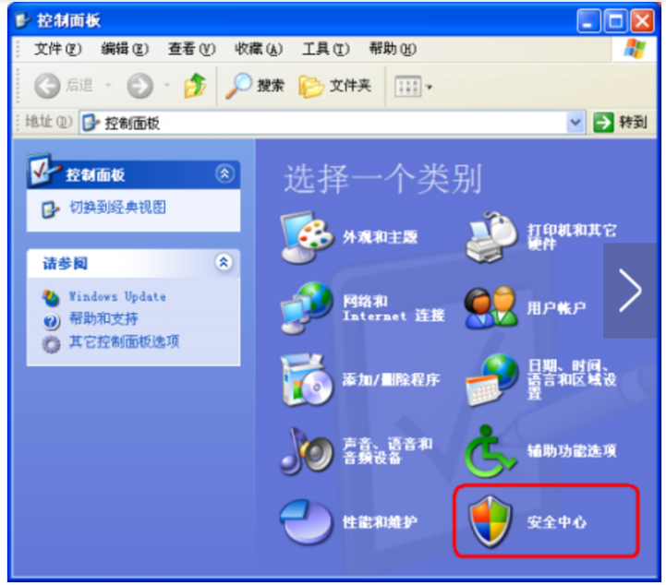

1. 点击 Windows防火墙

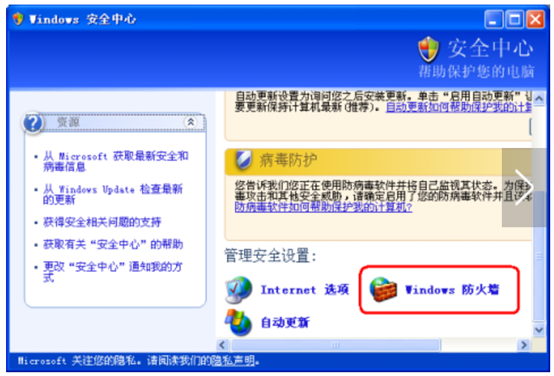

1. 点击【常规】选项卡

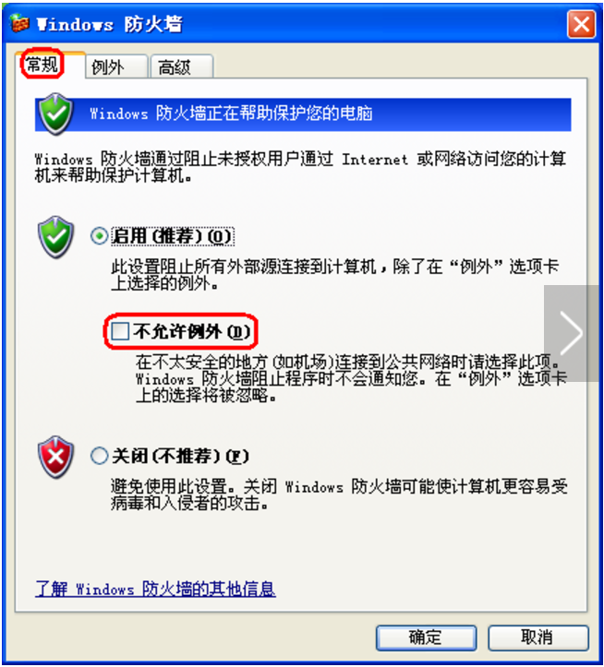

1. 点击【例外】选项卡，取消【文件和打印机共享】

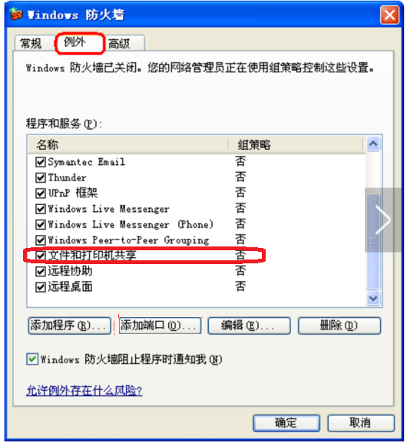

Windows 7以上版本操作系统

第一步：进入防火墙-》高级设置

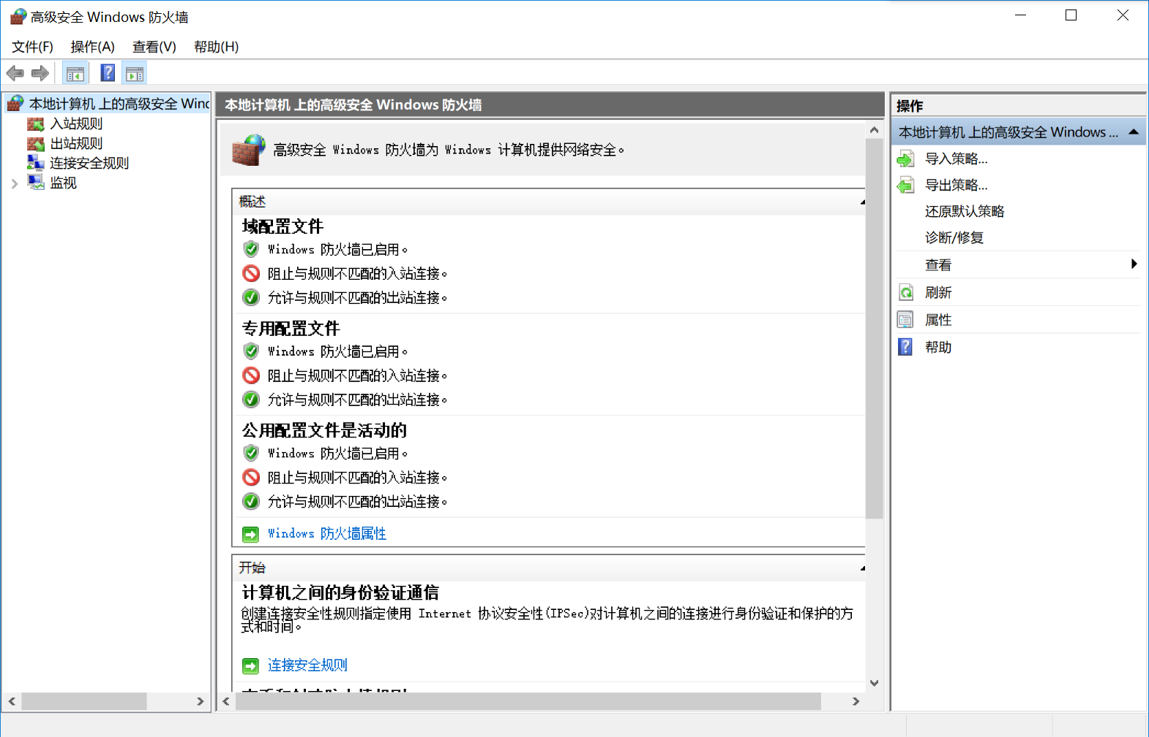

第二步：点击入站-》新建规则

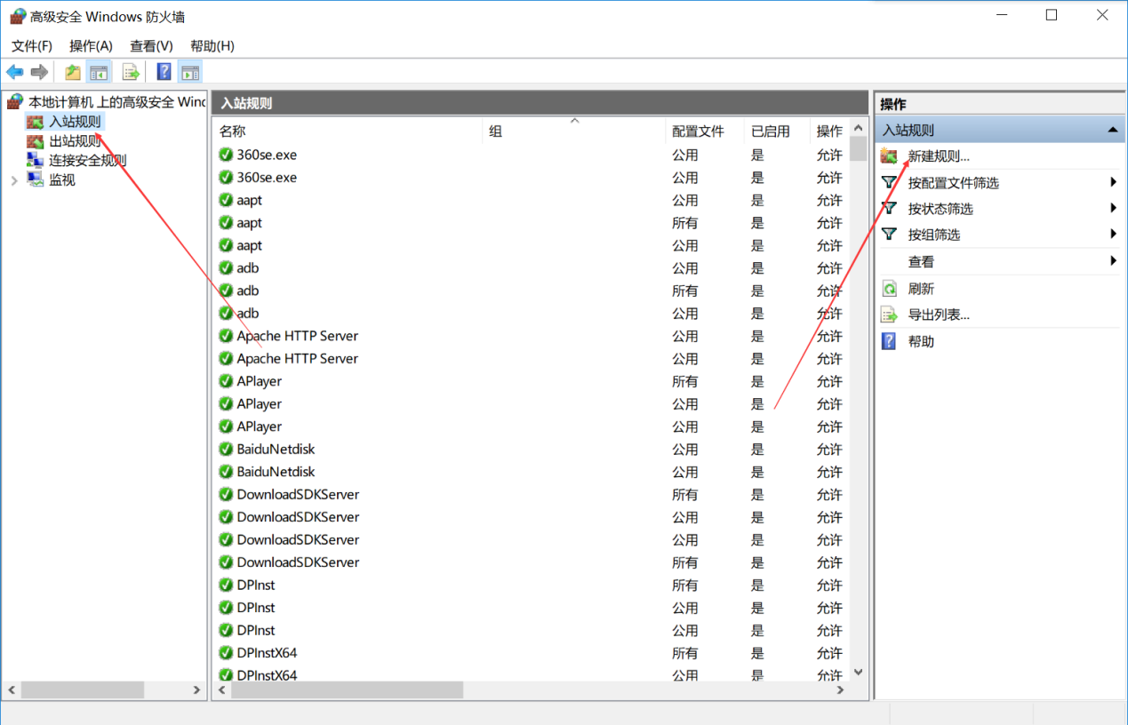

第三步：选端口-》下一步

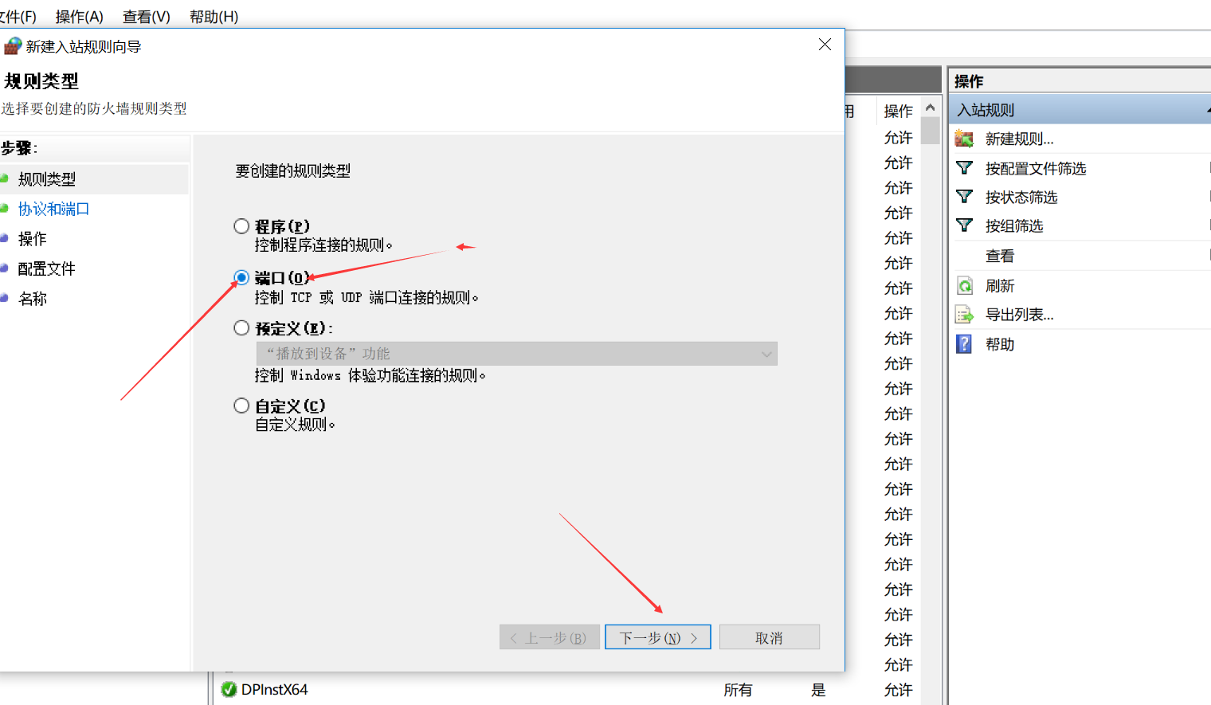

第四步：选TCP-》特定端口（135,137,138,139,445）

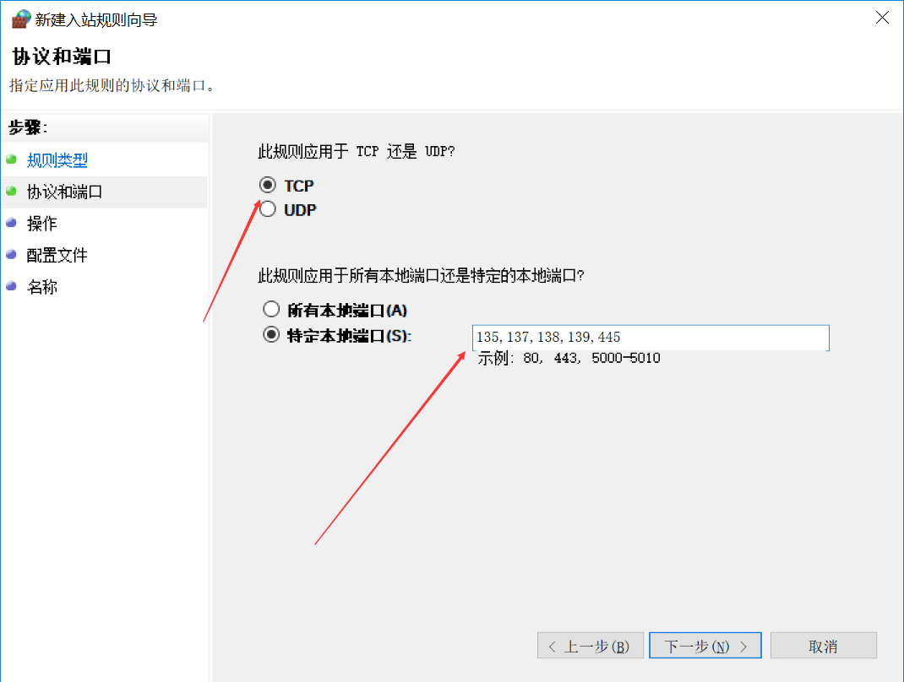

第五步：阻止连接-》下一步

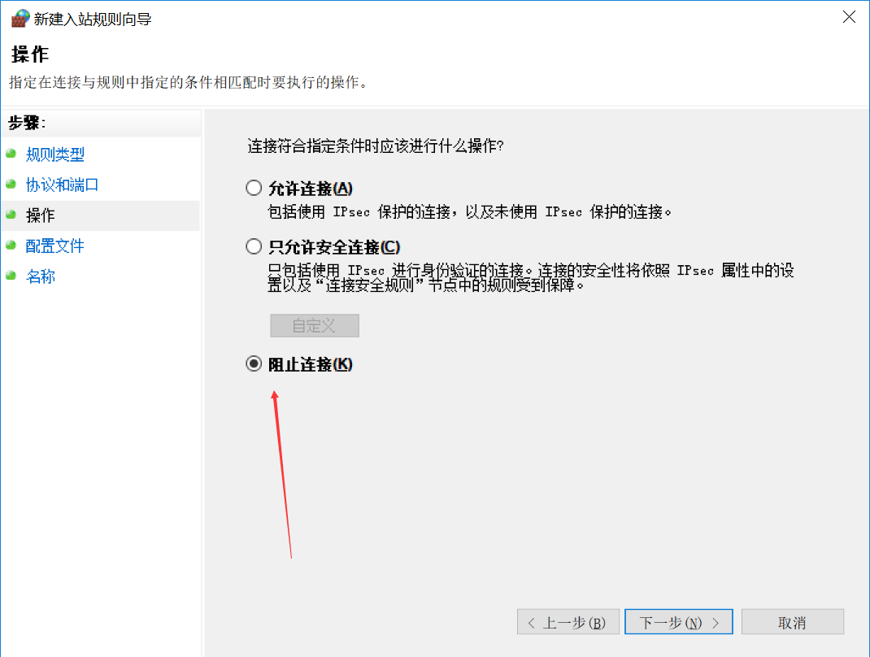

第六步：

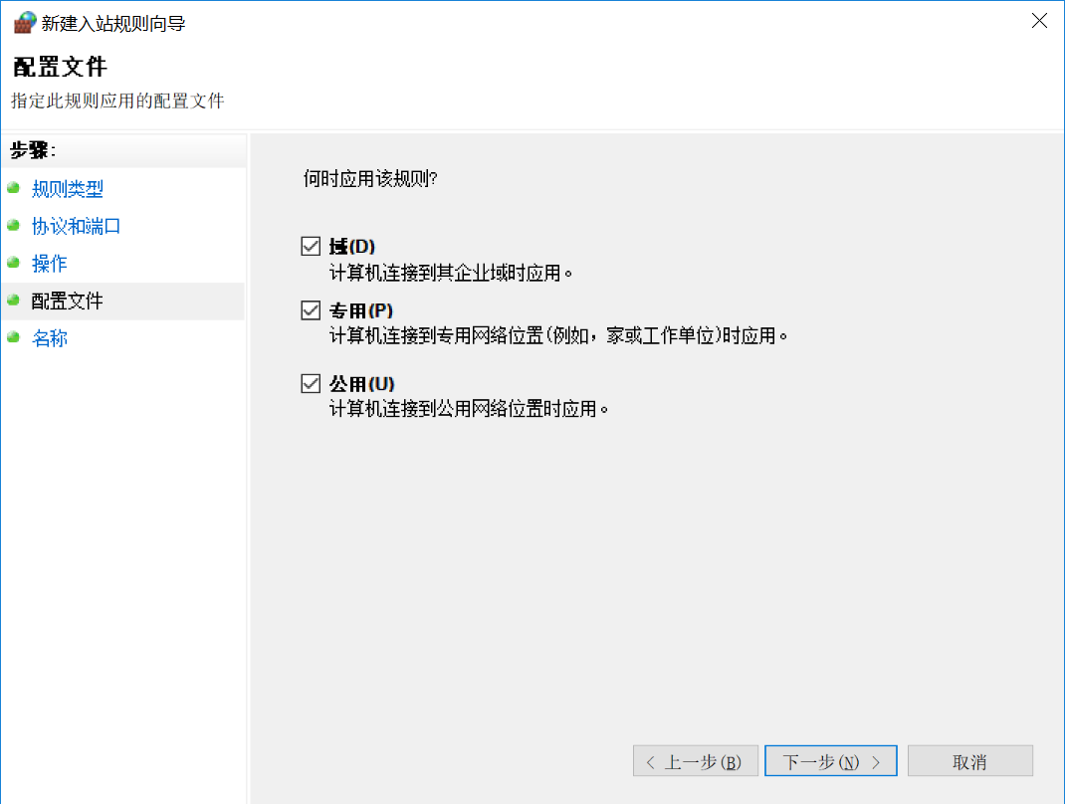

第七步：名字随便取-》完成

